Senior Infants

We have been very busy since we came back to school in September.
We’ve welcomed two new friends to our class and have made great new buddies with 5th Class and Ms Honner. We have had fun reading stories and playing games together. We’re looking forward to getting to know each other more during the year!

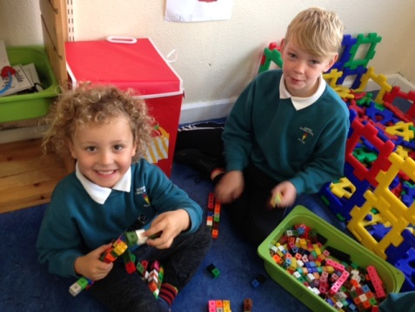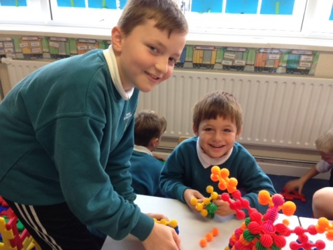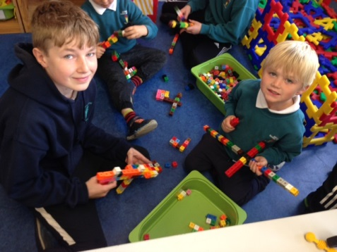
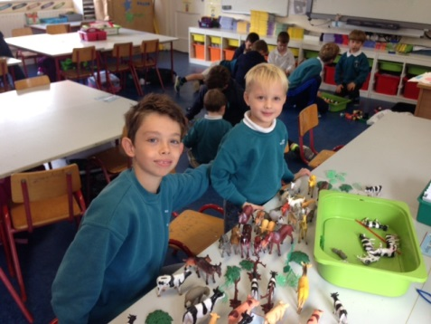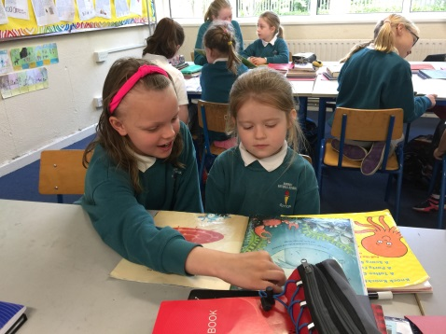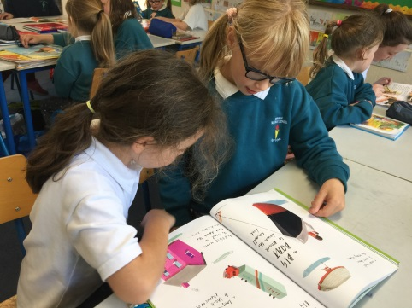
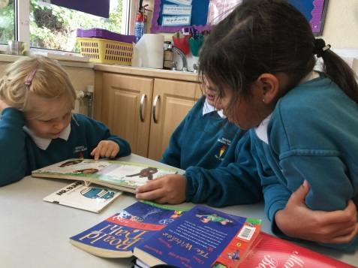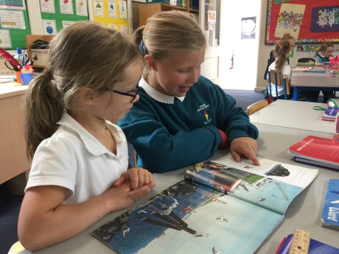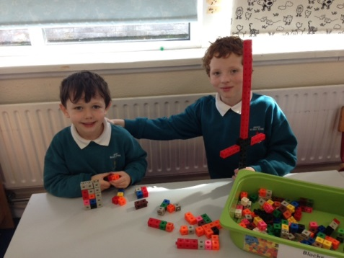

We’ve been really lucky to have Mrs McDermott as our teacher for the past month and have done some lovely art with her.

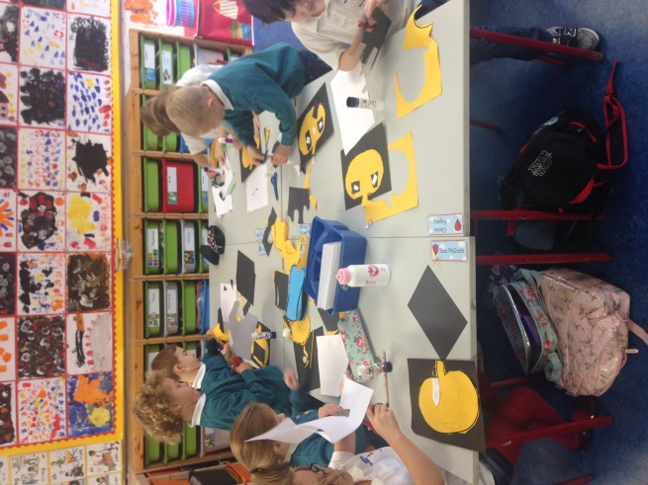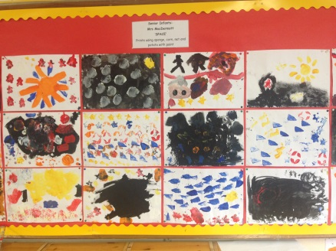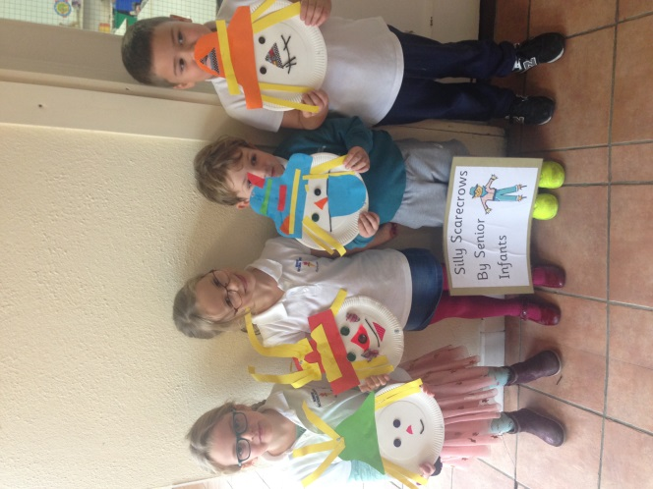

We have learnt how to do programming on the ipads and are learning two new songs on the violin. We’ve had visits from Benson Bear and Karen Mc Sweeney and we got to do extra special drama with Natasha King during book week. We’ve celebrated some birthdays, lost some teeth and are all really looking forward to dressing up for Halloween!

