0n day one of junior infants we measured the height of all the children, we used string to represent their height and sent it home with this little poem as a keep sake for their families on the momentous occasion of their child starting primary school.
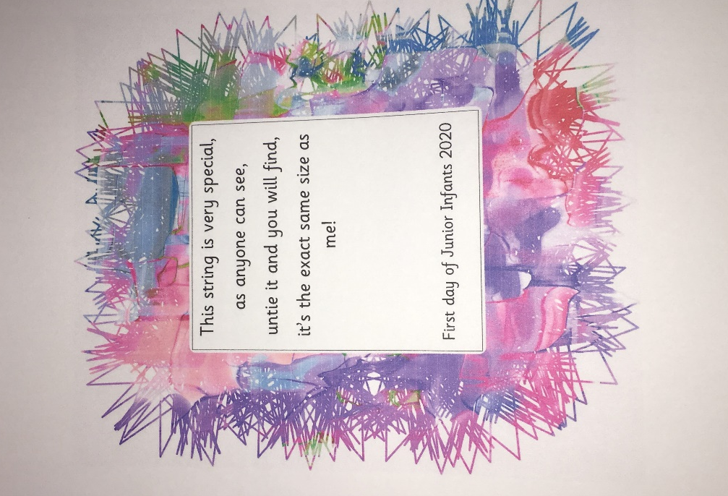
We enjoyed a BBQ on a very sunny day in the garden.
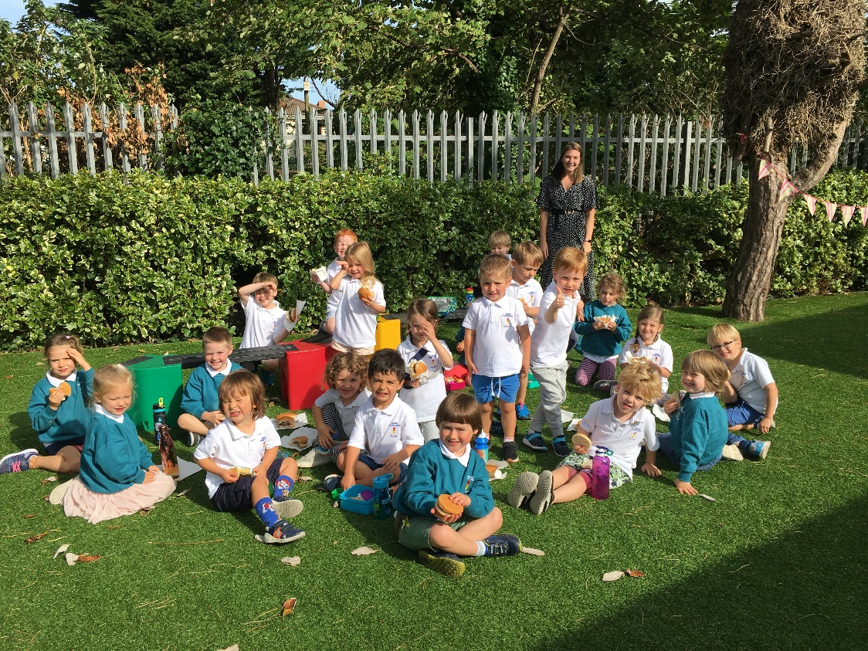
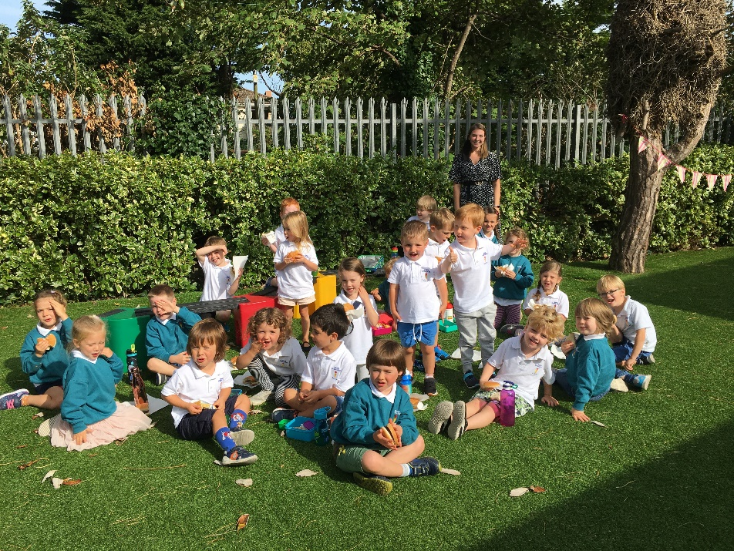

We were learning about houses and the various rooms in SESE the children loved the use of ICT for this, we explored houses on google maps and even looked up the school. 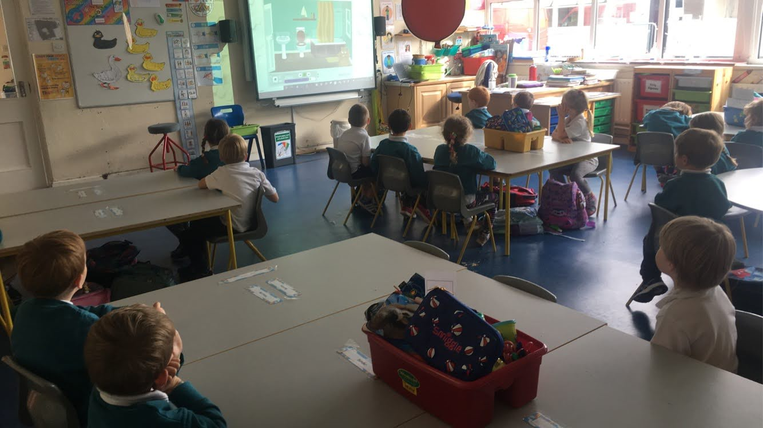

We have done a lot of work based around the theme of Autumn the class has made some impressive artwork using a variety of techniques. 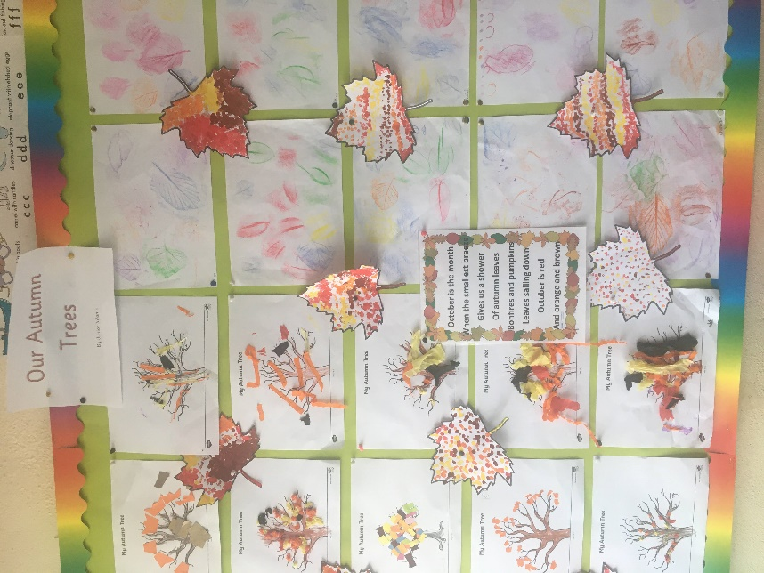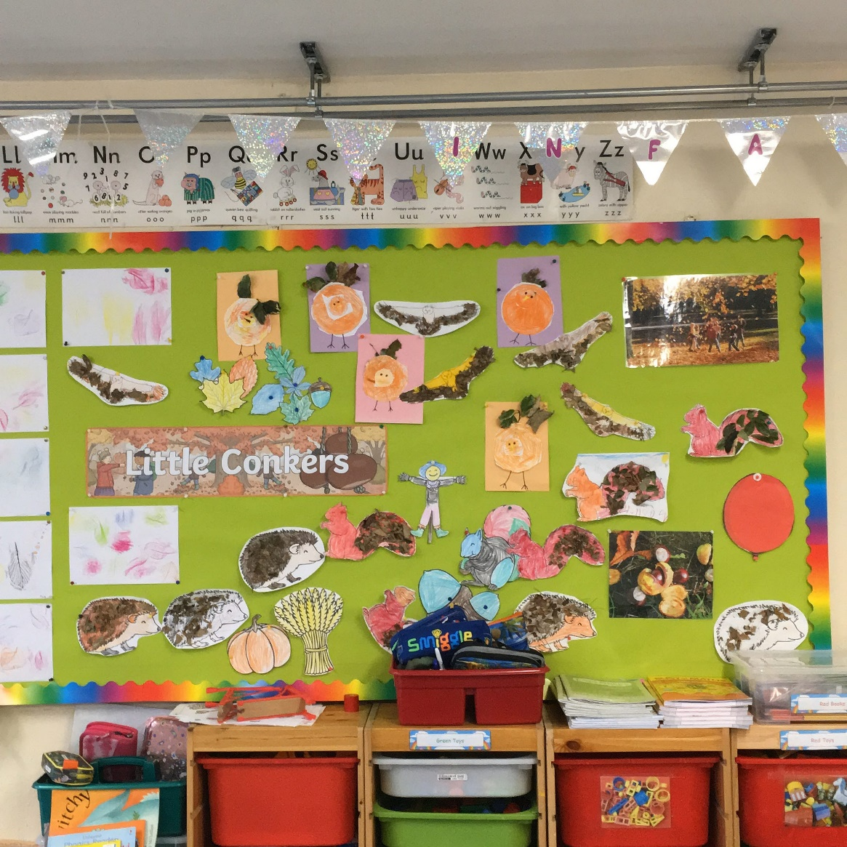

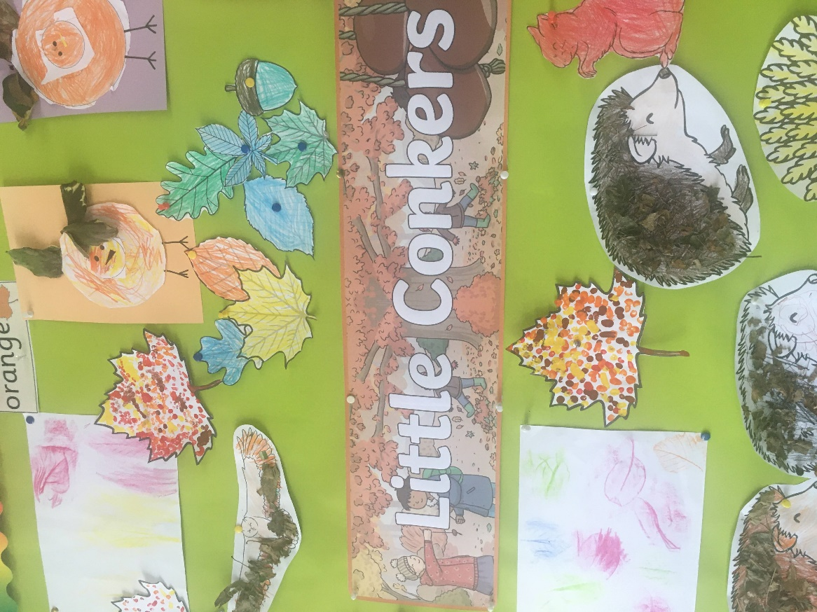
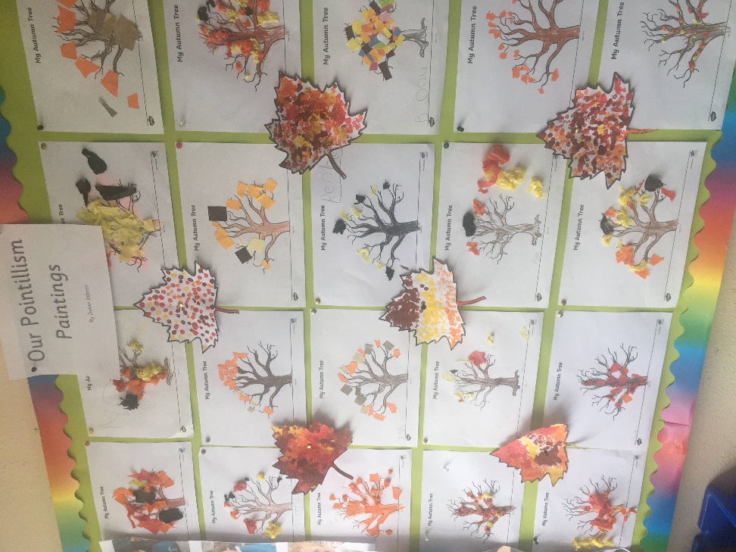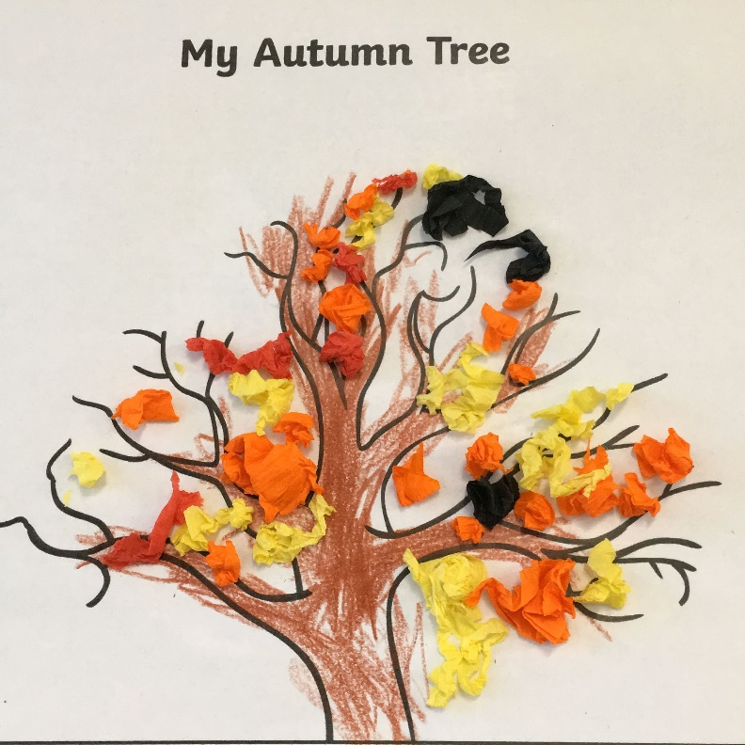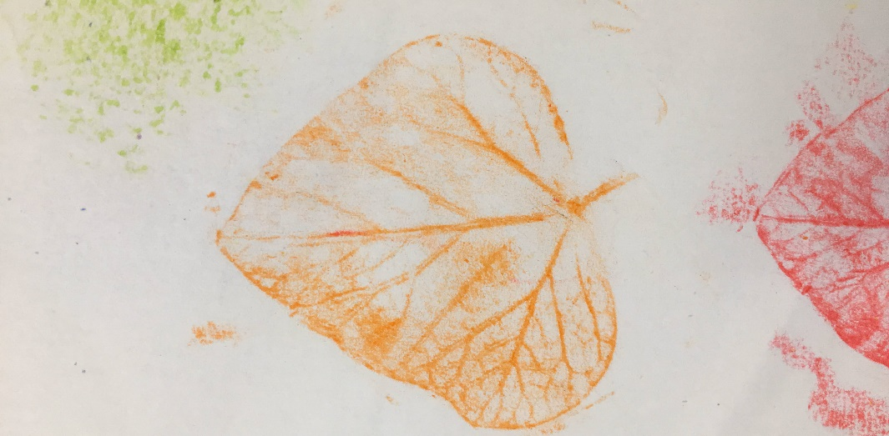

We have morning play where the class play within their pod groups, developing essential social skills. This has been a great time for team bonding within our pods the relationships between pupils are really blossoming.
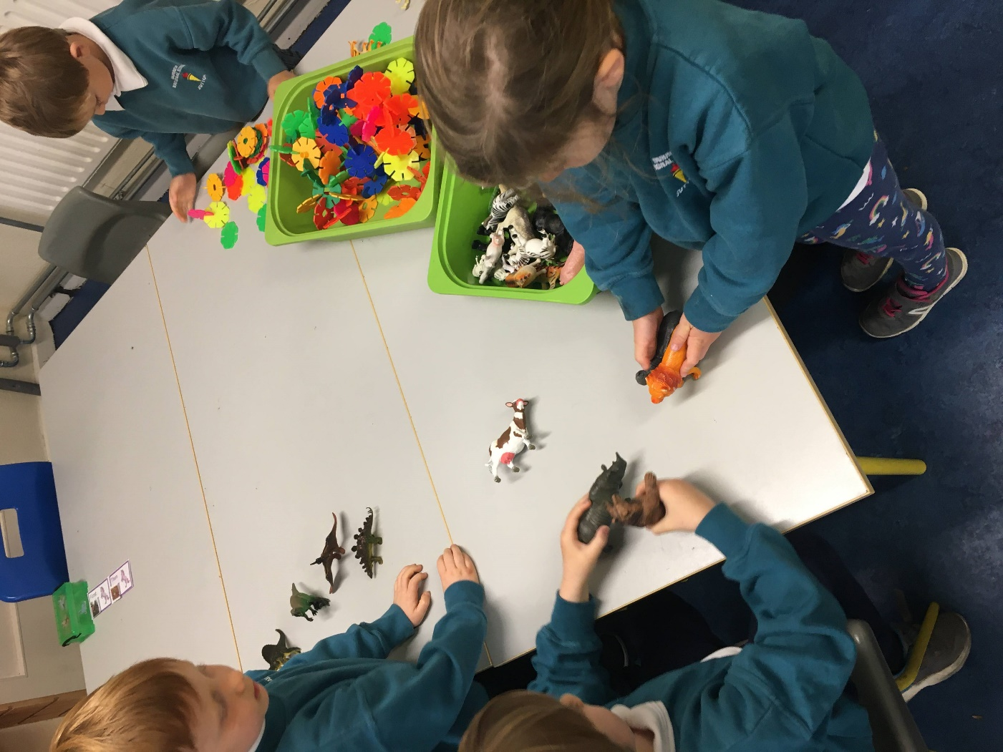
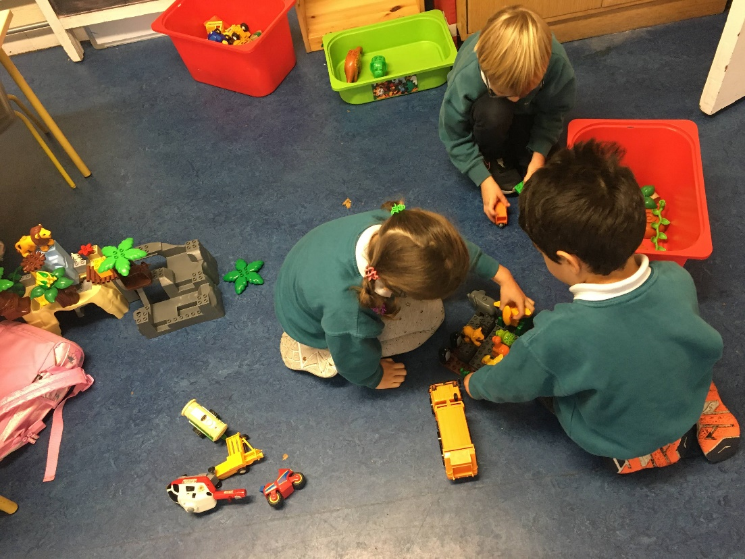
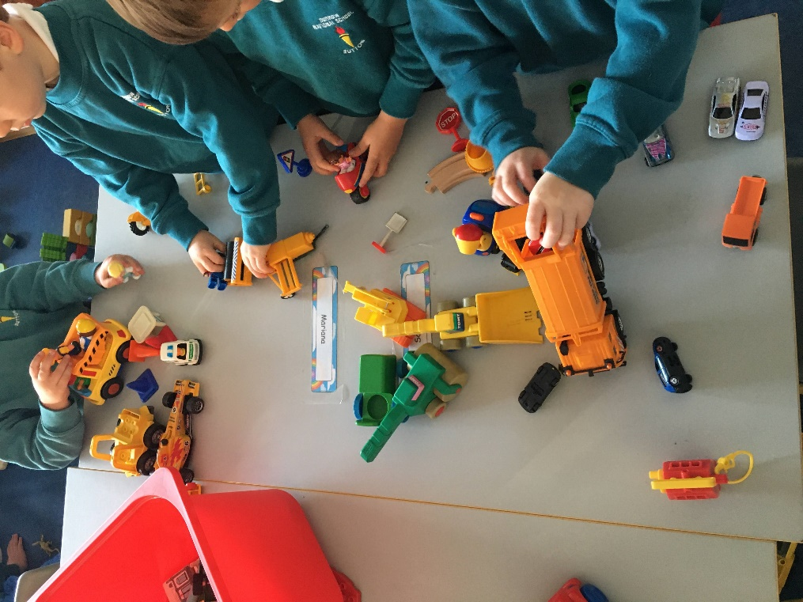

We were learning all about length, and height in maths, we used our morning play toys to build short and tall towers, and we used our individual play dough pots to make short and long snakes the children benefit a lot from all the fine and gross motor hands on learning. 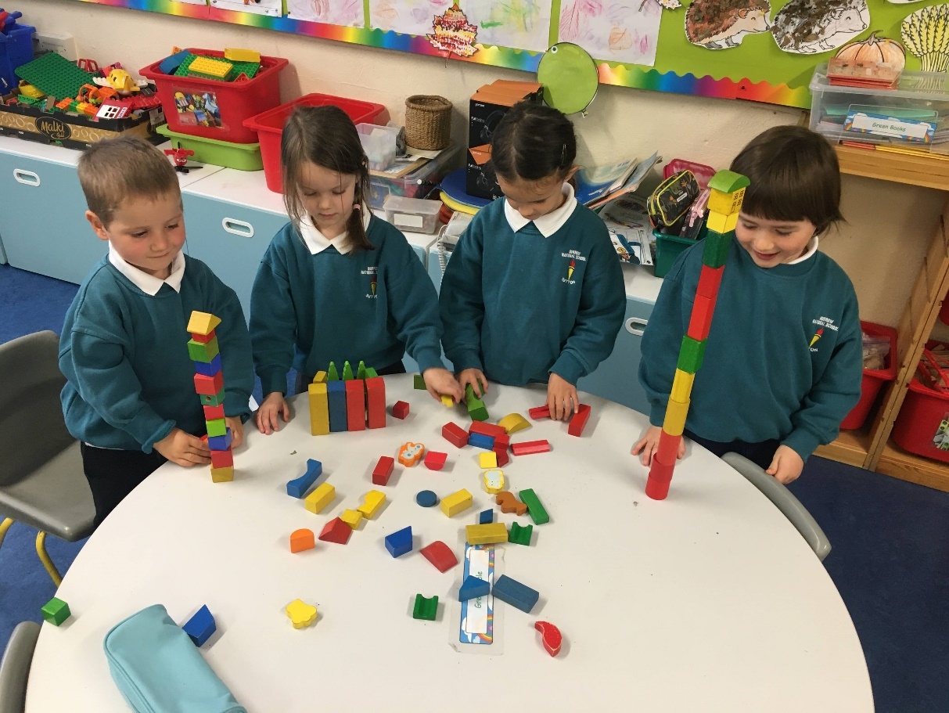
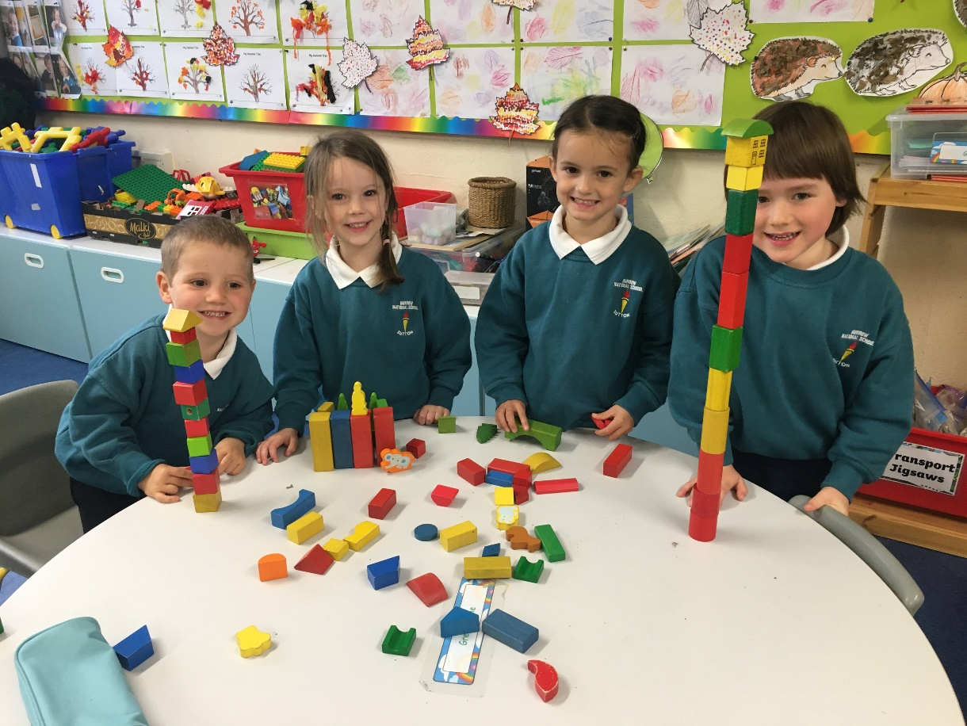

Our Aistear stations are in weekly rotation the theme for our first month was School, the children had great fun in the roleplay area impersonating pupils, teachers, caretakers, secretaries, principals and SNA’s. They used construction toys to build the equipment used in our school and classroom. We used the iPads to practice our phonics so far, we have learnt S, A, T, P, I and N. The children had playdough mats based around school and the classroom surroundings they enjoyed creating a wide variety of objects used and found in school.
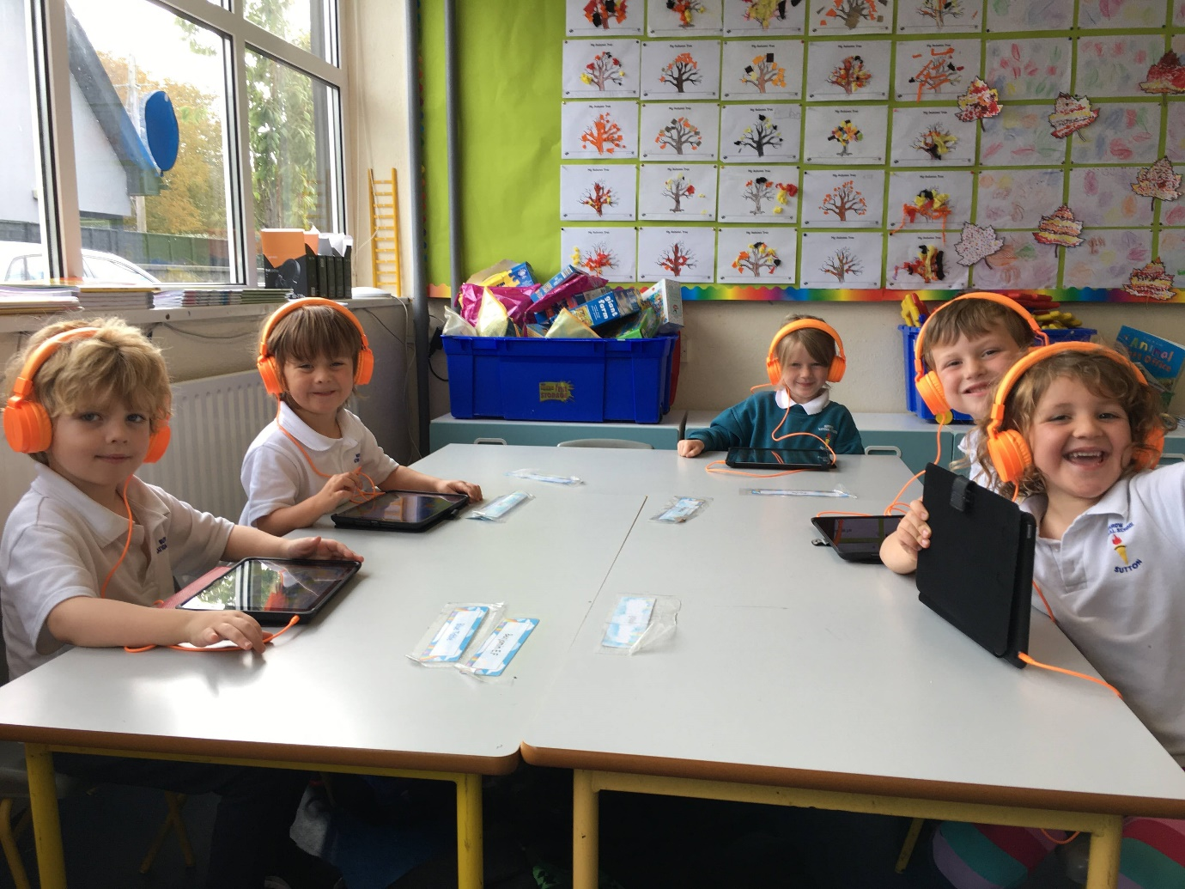
We have been working on our fine motor skills every Friday, through station teaching with the much-appreciated help of Mrs. Flanagan. Our five stations are peg boards, playdough, large bead threading, small bead threading and pom poms which are moved using only jumbo tweezers or clothes pegs developing pincer grip and hand/arm strength.
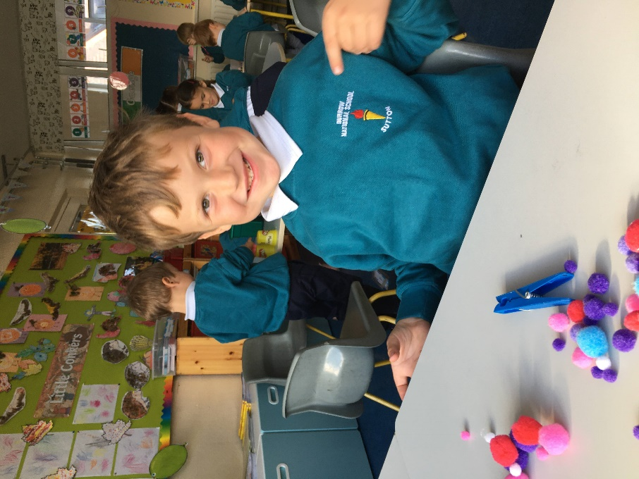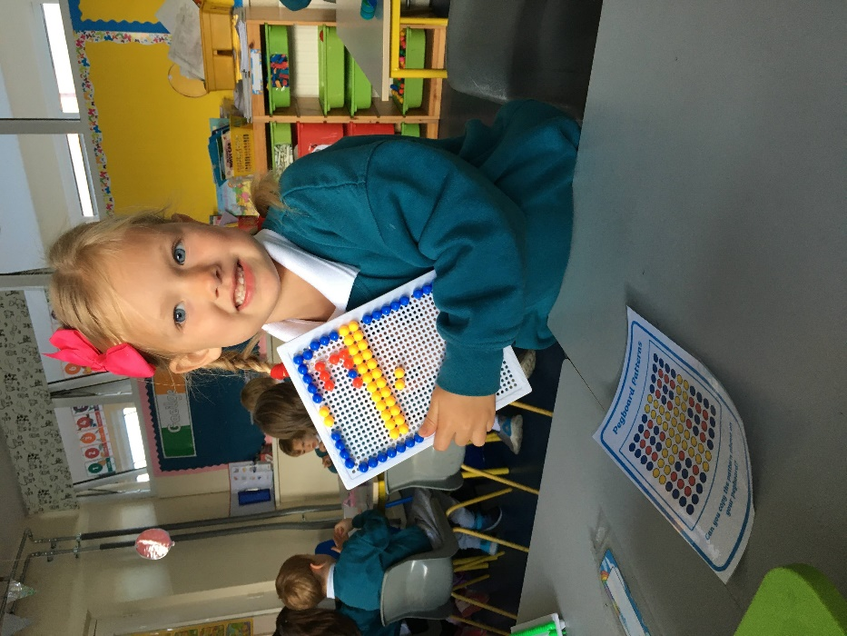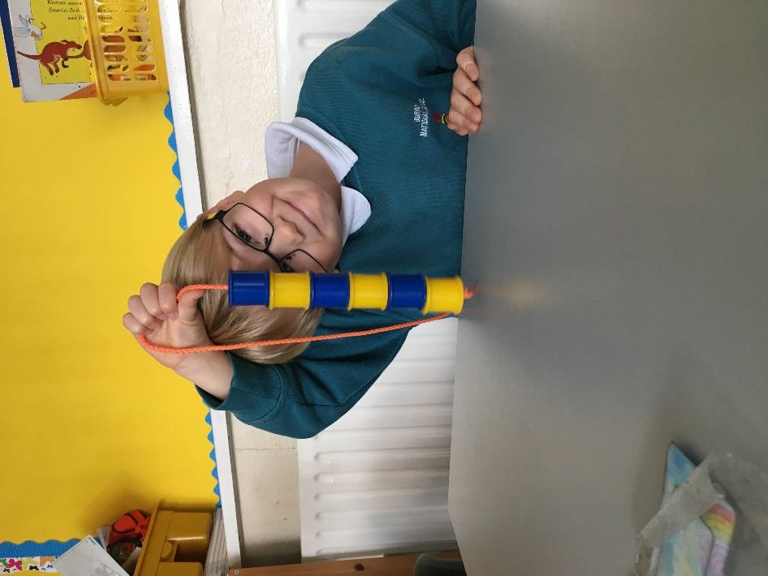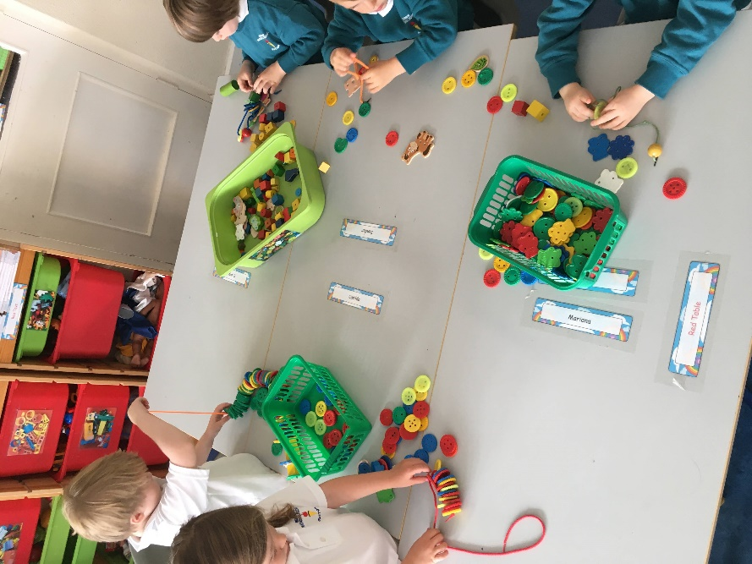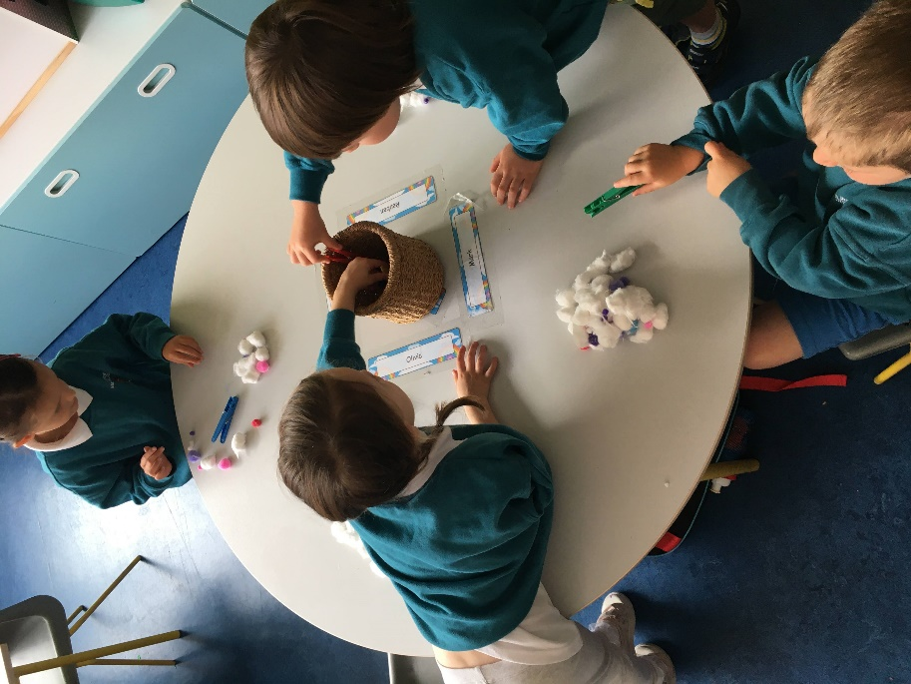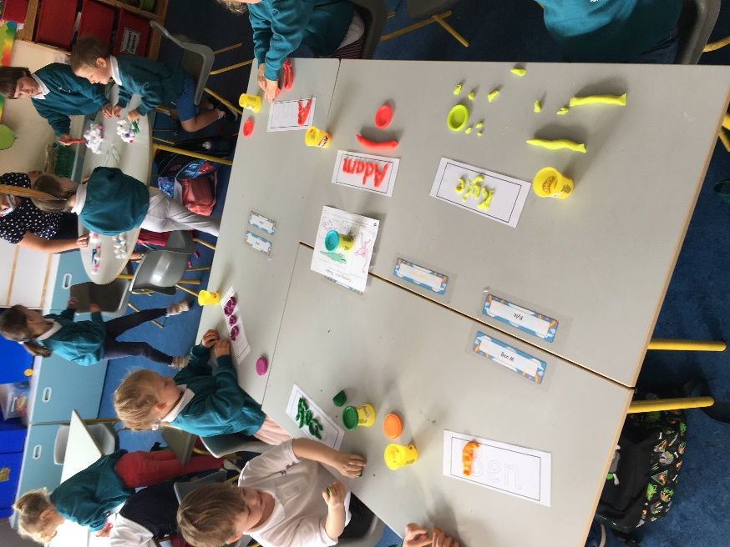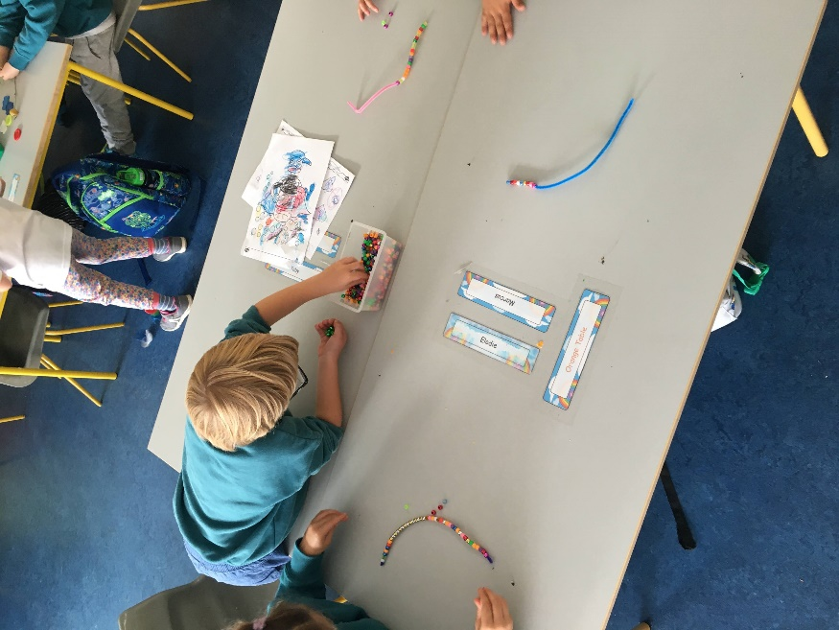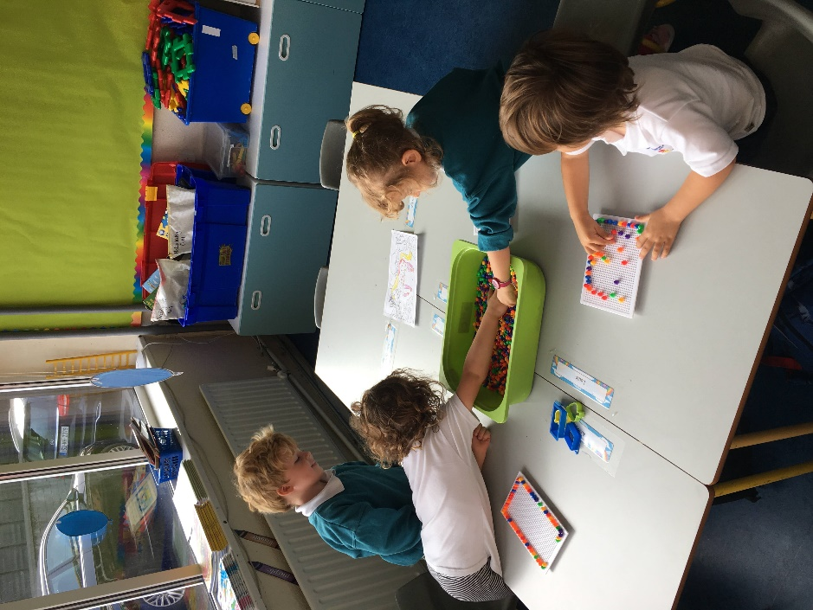

Our art for the end of this term has revolved around decorating our classroom to getting into the spirit for Halloween, we created pumpkins who can be spotted along our corridor having a party.
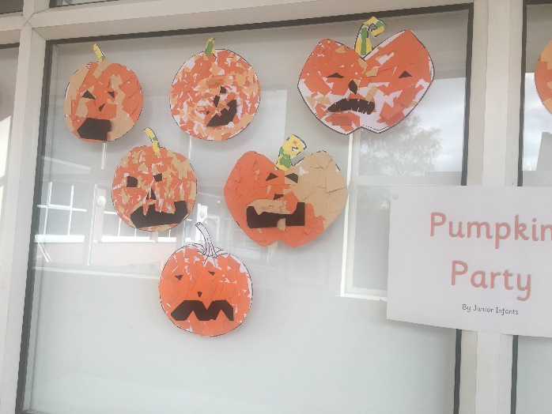
We created tissue paper ghosts, mostly called ‘púca’ as we are following the now integrated language curriculum which focuses on the blending of the English and Irish language. 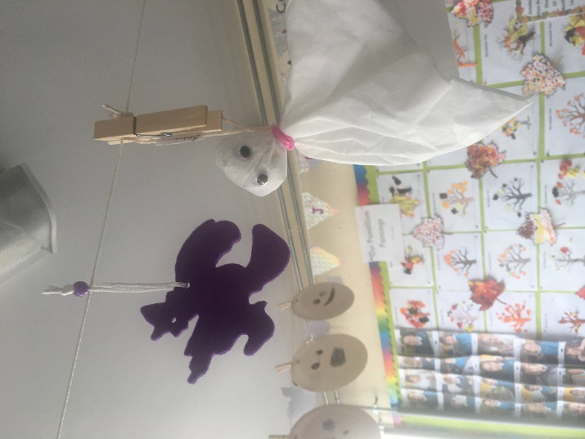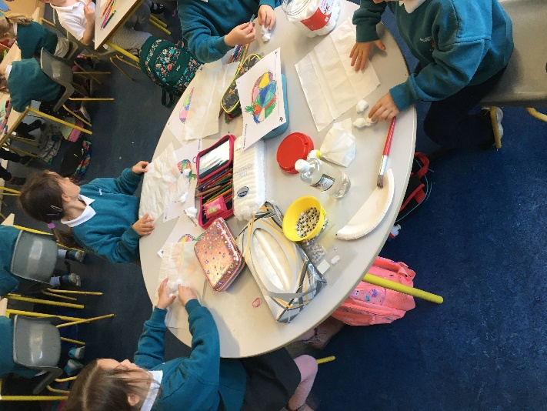
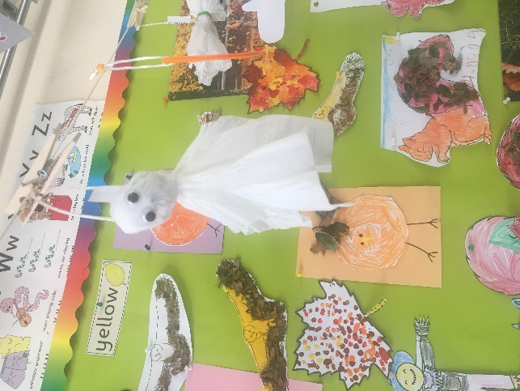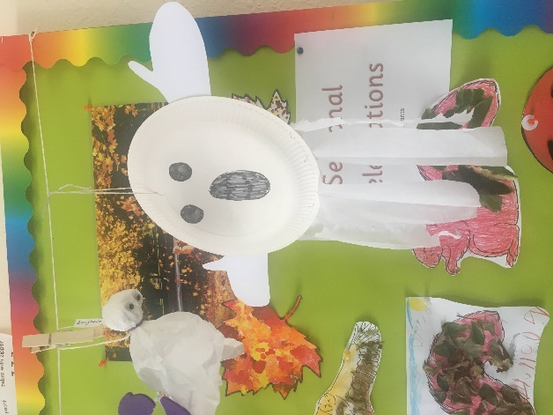
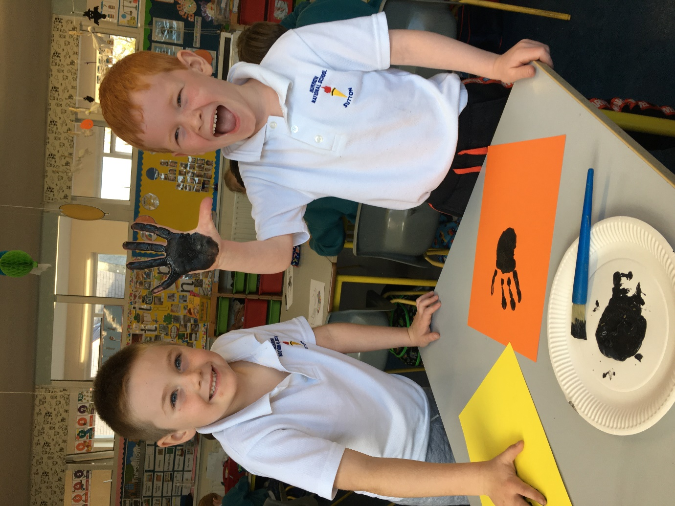
We created spiders using our handprints.

