Senior Infants
Senior Infants have been super busy since we have come back to school after our Halloween break!
We finished up with soccer with our FAI coaches. A huge thank you to the coaches from all of us in Senior Infants. We had great fun learning new skills each week.

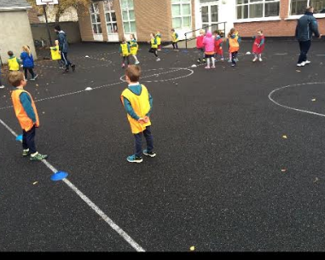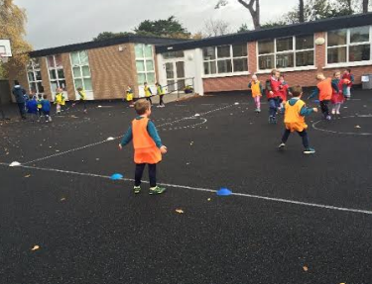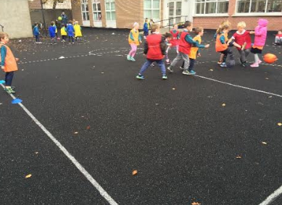

We were very lucky to have Brian Howard and our GAA coach Paddy, arrive into school with the Sam Maguire cup. Up the Dubs!
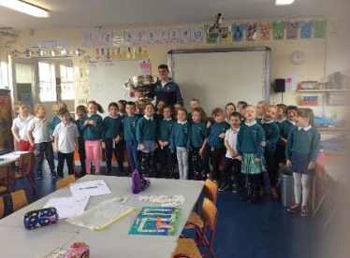
We got the opportunity to be an audience for fourth class as they played some tunes on the tin whistle for us. Well done fourth class.
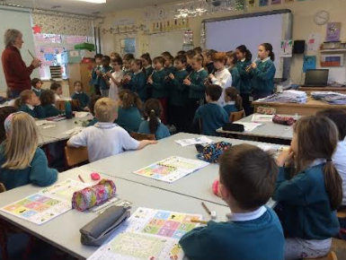
Senior infants have truly been getting into the Christmas spirit. We made fairy doors and snowmen which were sold at the Burrow Christmas Fair..
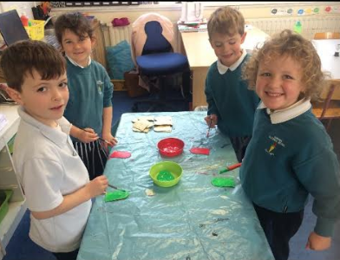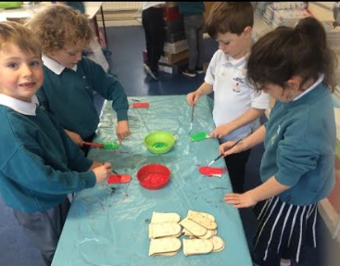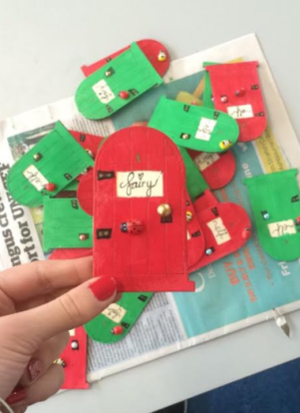
We spent some time reading lovely Christmas stories, and of course, we put together a wonderful Nativity Play
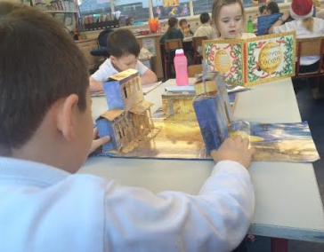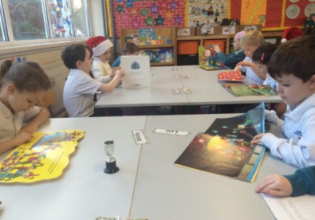
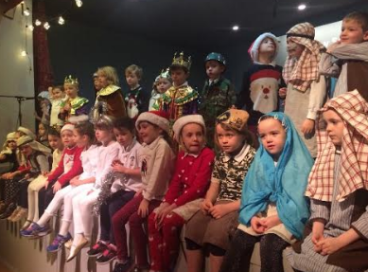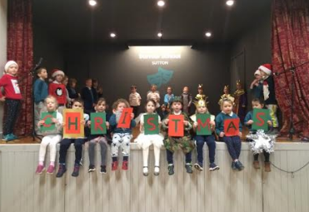

From all of us in Senior Infants we wish you a very merry and safe Christmas.

