Junior Infants
Junior Infants have been very busy since they arrived in September. They spent a lot of time getting to know their new class room, the school and all the teachers. They also had lots of new friends to get to know and names to learn!
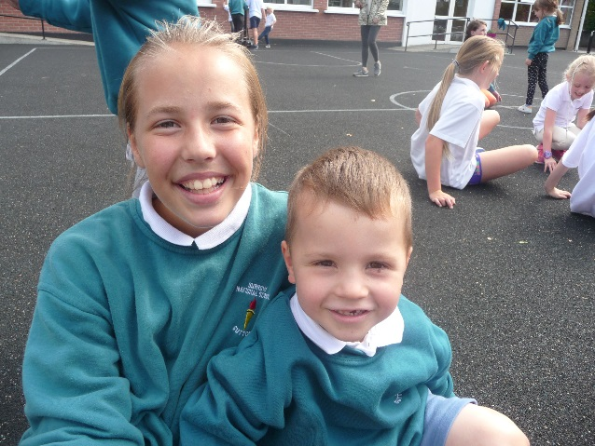
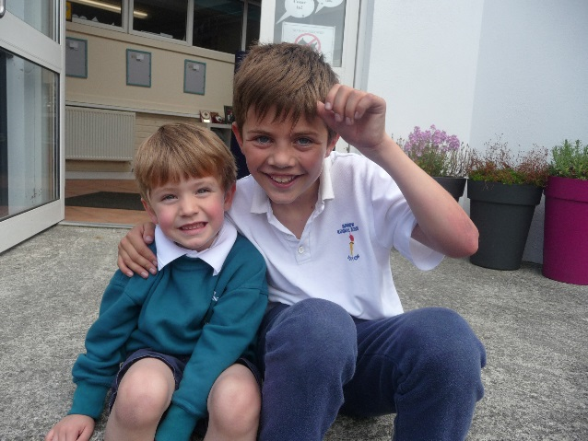
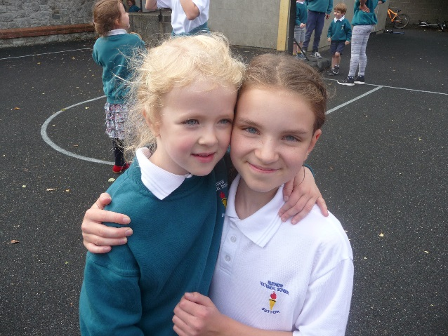
Probably most exciting was getting to know their new 6th Class buddies. They spent time playing, reading books and singing songs together.
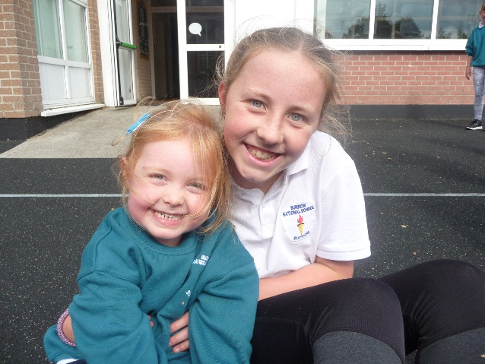
Junior Infants have learned how to hold their pencils correctly, using the ‘Nip, Flip and Grip’ technique to make their ‘Froggy Fingers’. They completed lots of colouring tasks and pre-writing tasks to practise this and learned to write their names. We even chose a writer of the month for the best name. It was won by Katie and is displayed the school corridor.

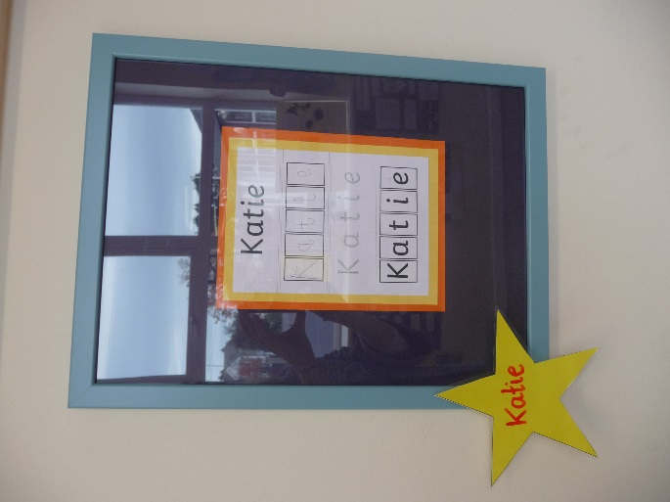

In October Junior Infants started homework…. which was very exciting!!! They also started their Jolly Phonics programme and have completed their first set of letters / sounds. They love the songs and actions and are doing really well with their letter formation.
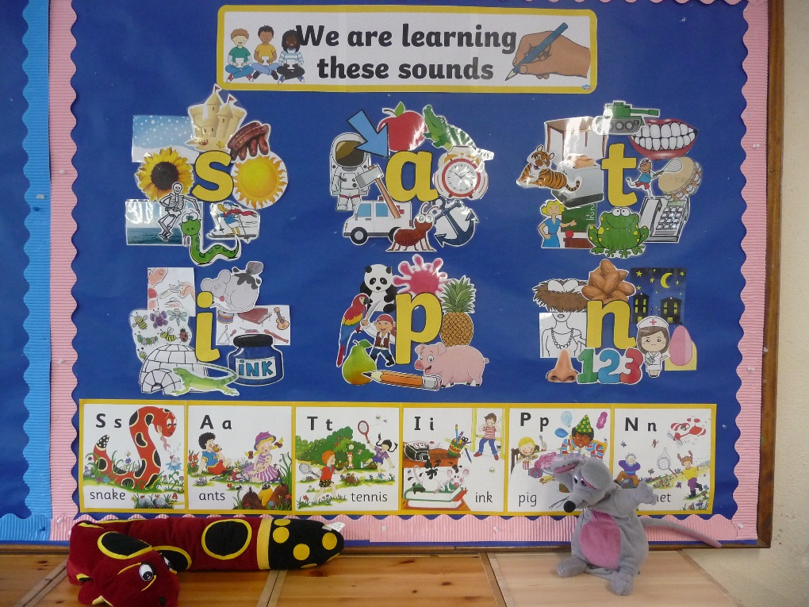

We spent a lot of time learning about ourselves and how we have grown and changed since we were babies. We talked about how our clothes, food, toys and responsibilities have changed. Junior Infants collected a few baby items from home and brought them in to show the class. They also gathered photos from when they were babies and we have great fun guessing which baby photo went with which child.

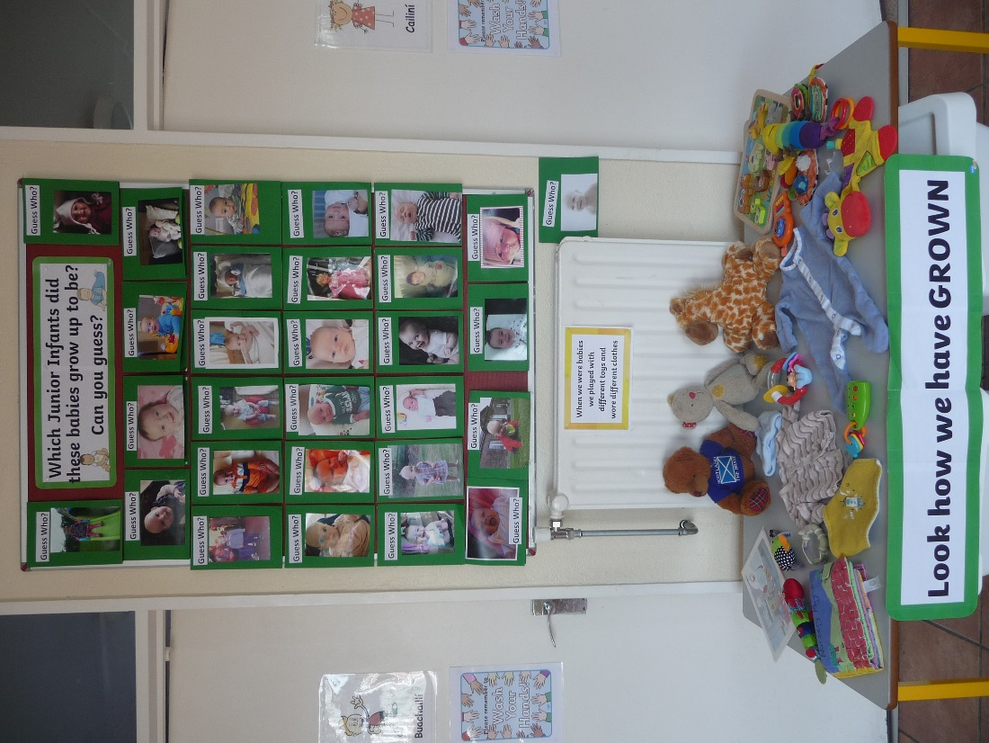

We had a student teacher called Ms. Edie in class helping us for a few weeks and she has been doing a project with Junior Infants and 6th Class each Friday. Together with their buddies the pupils have been writing and illustrating their own short stories using interesting story starter pictures as inspiration. We hope to have our very own book of short stories soon.
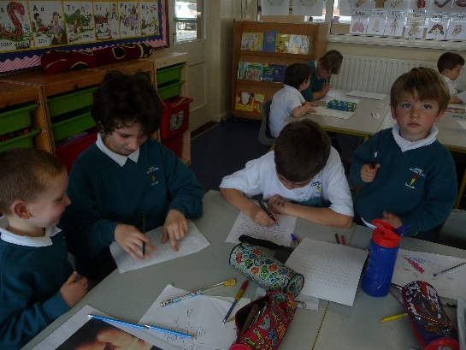
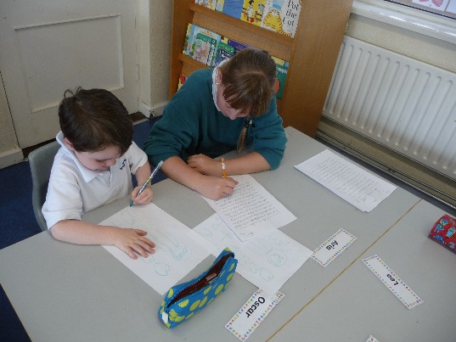
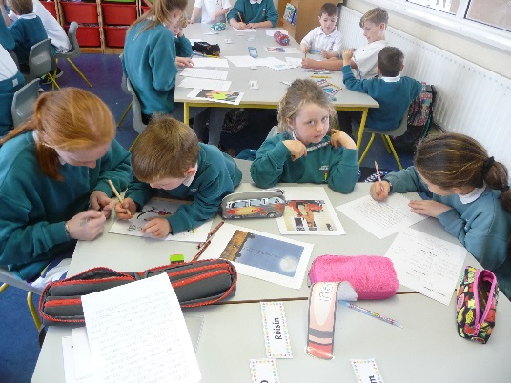

And that is just a small part of it. We’ve also taken part in book week, dressed up as book characters, played the violin each week, done some lovely art, survived a hurricane, played GAA, eaten doughnuts, performed at and lead the assembly and much, much more!

