6th Class
Here are 6th class at the Rubgy Blitz in Suttonians:
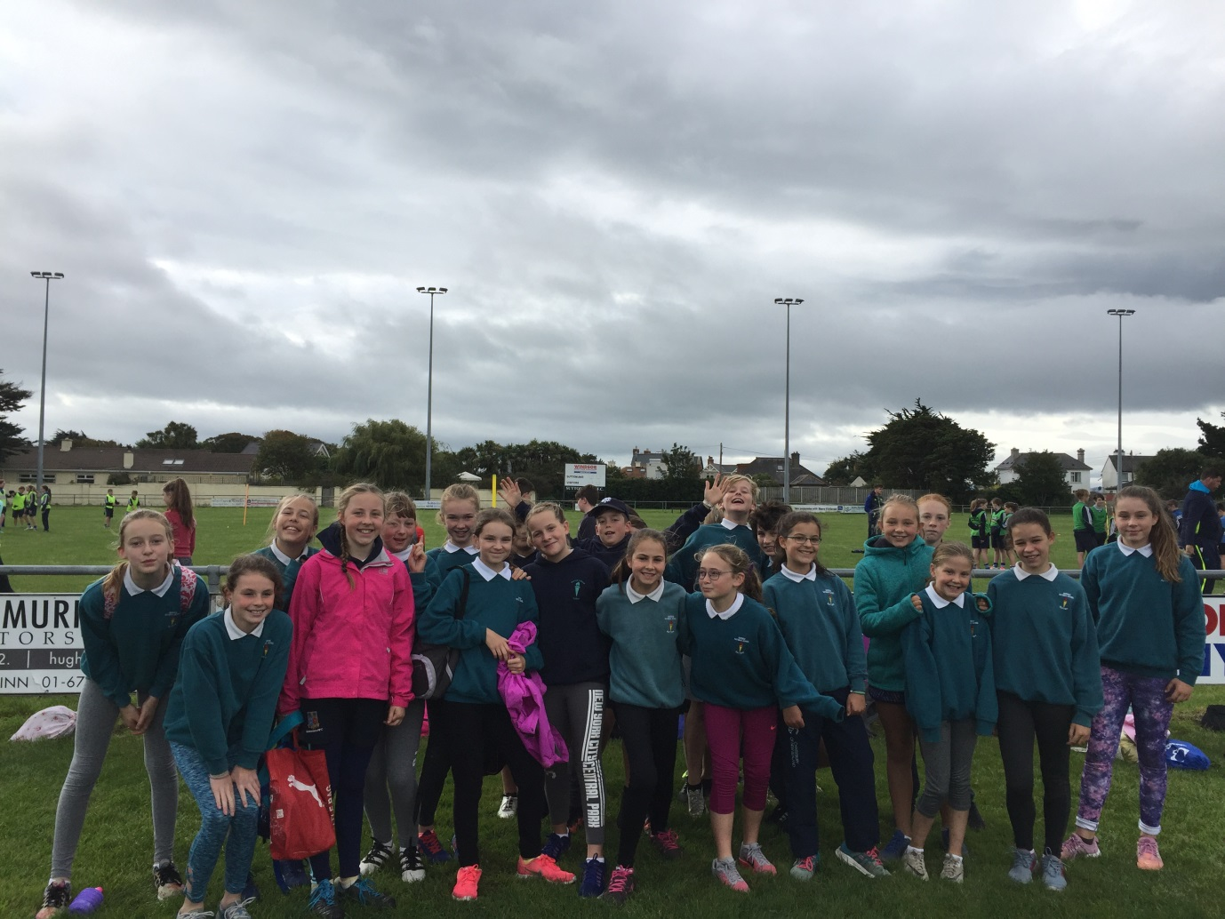

Here are 6th class doing their freeze frame of Charlie and the Chocolate Factory after their drama session with Natasha King during Book Week:
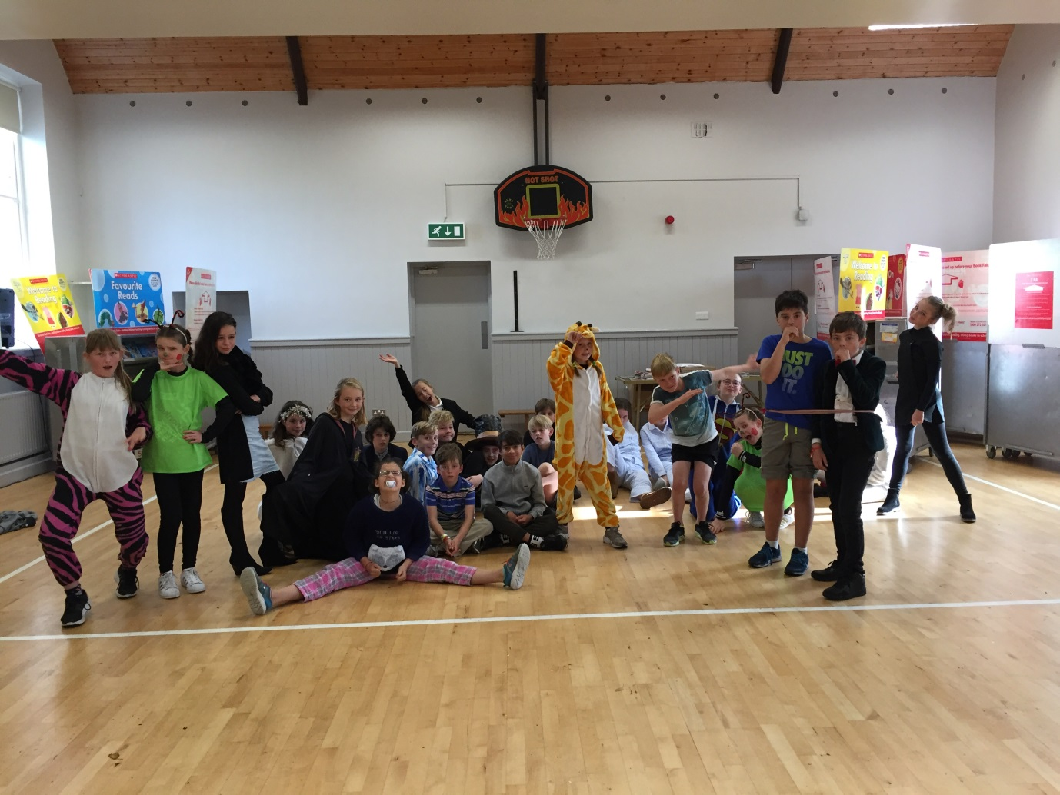

Here’s Lauren in the Cloak of Howth after a visit from Patrick Jackson. All of the items on the cloak were found around the beaches of Howth:
