We were very lucky to have Bricks 4 Kids in with us in first class! Our class were busy following a manual and using Lego pieces to build a windmill. We even connected a battery pack to make the windmill spin! We all had lots of fun and really enjoyed building our own models!

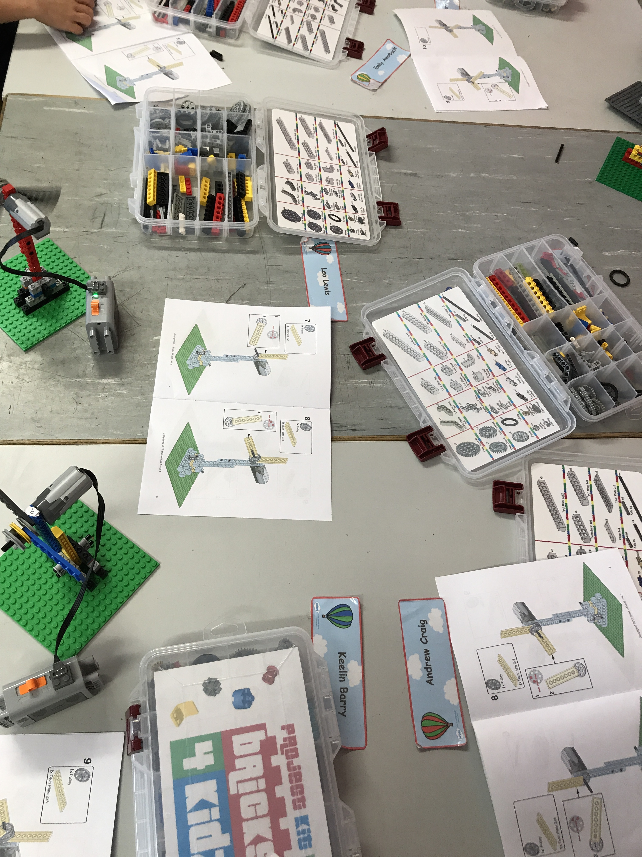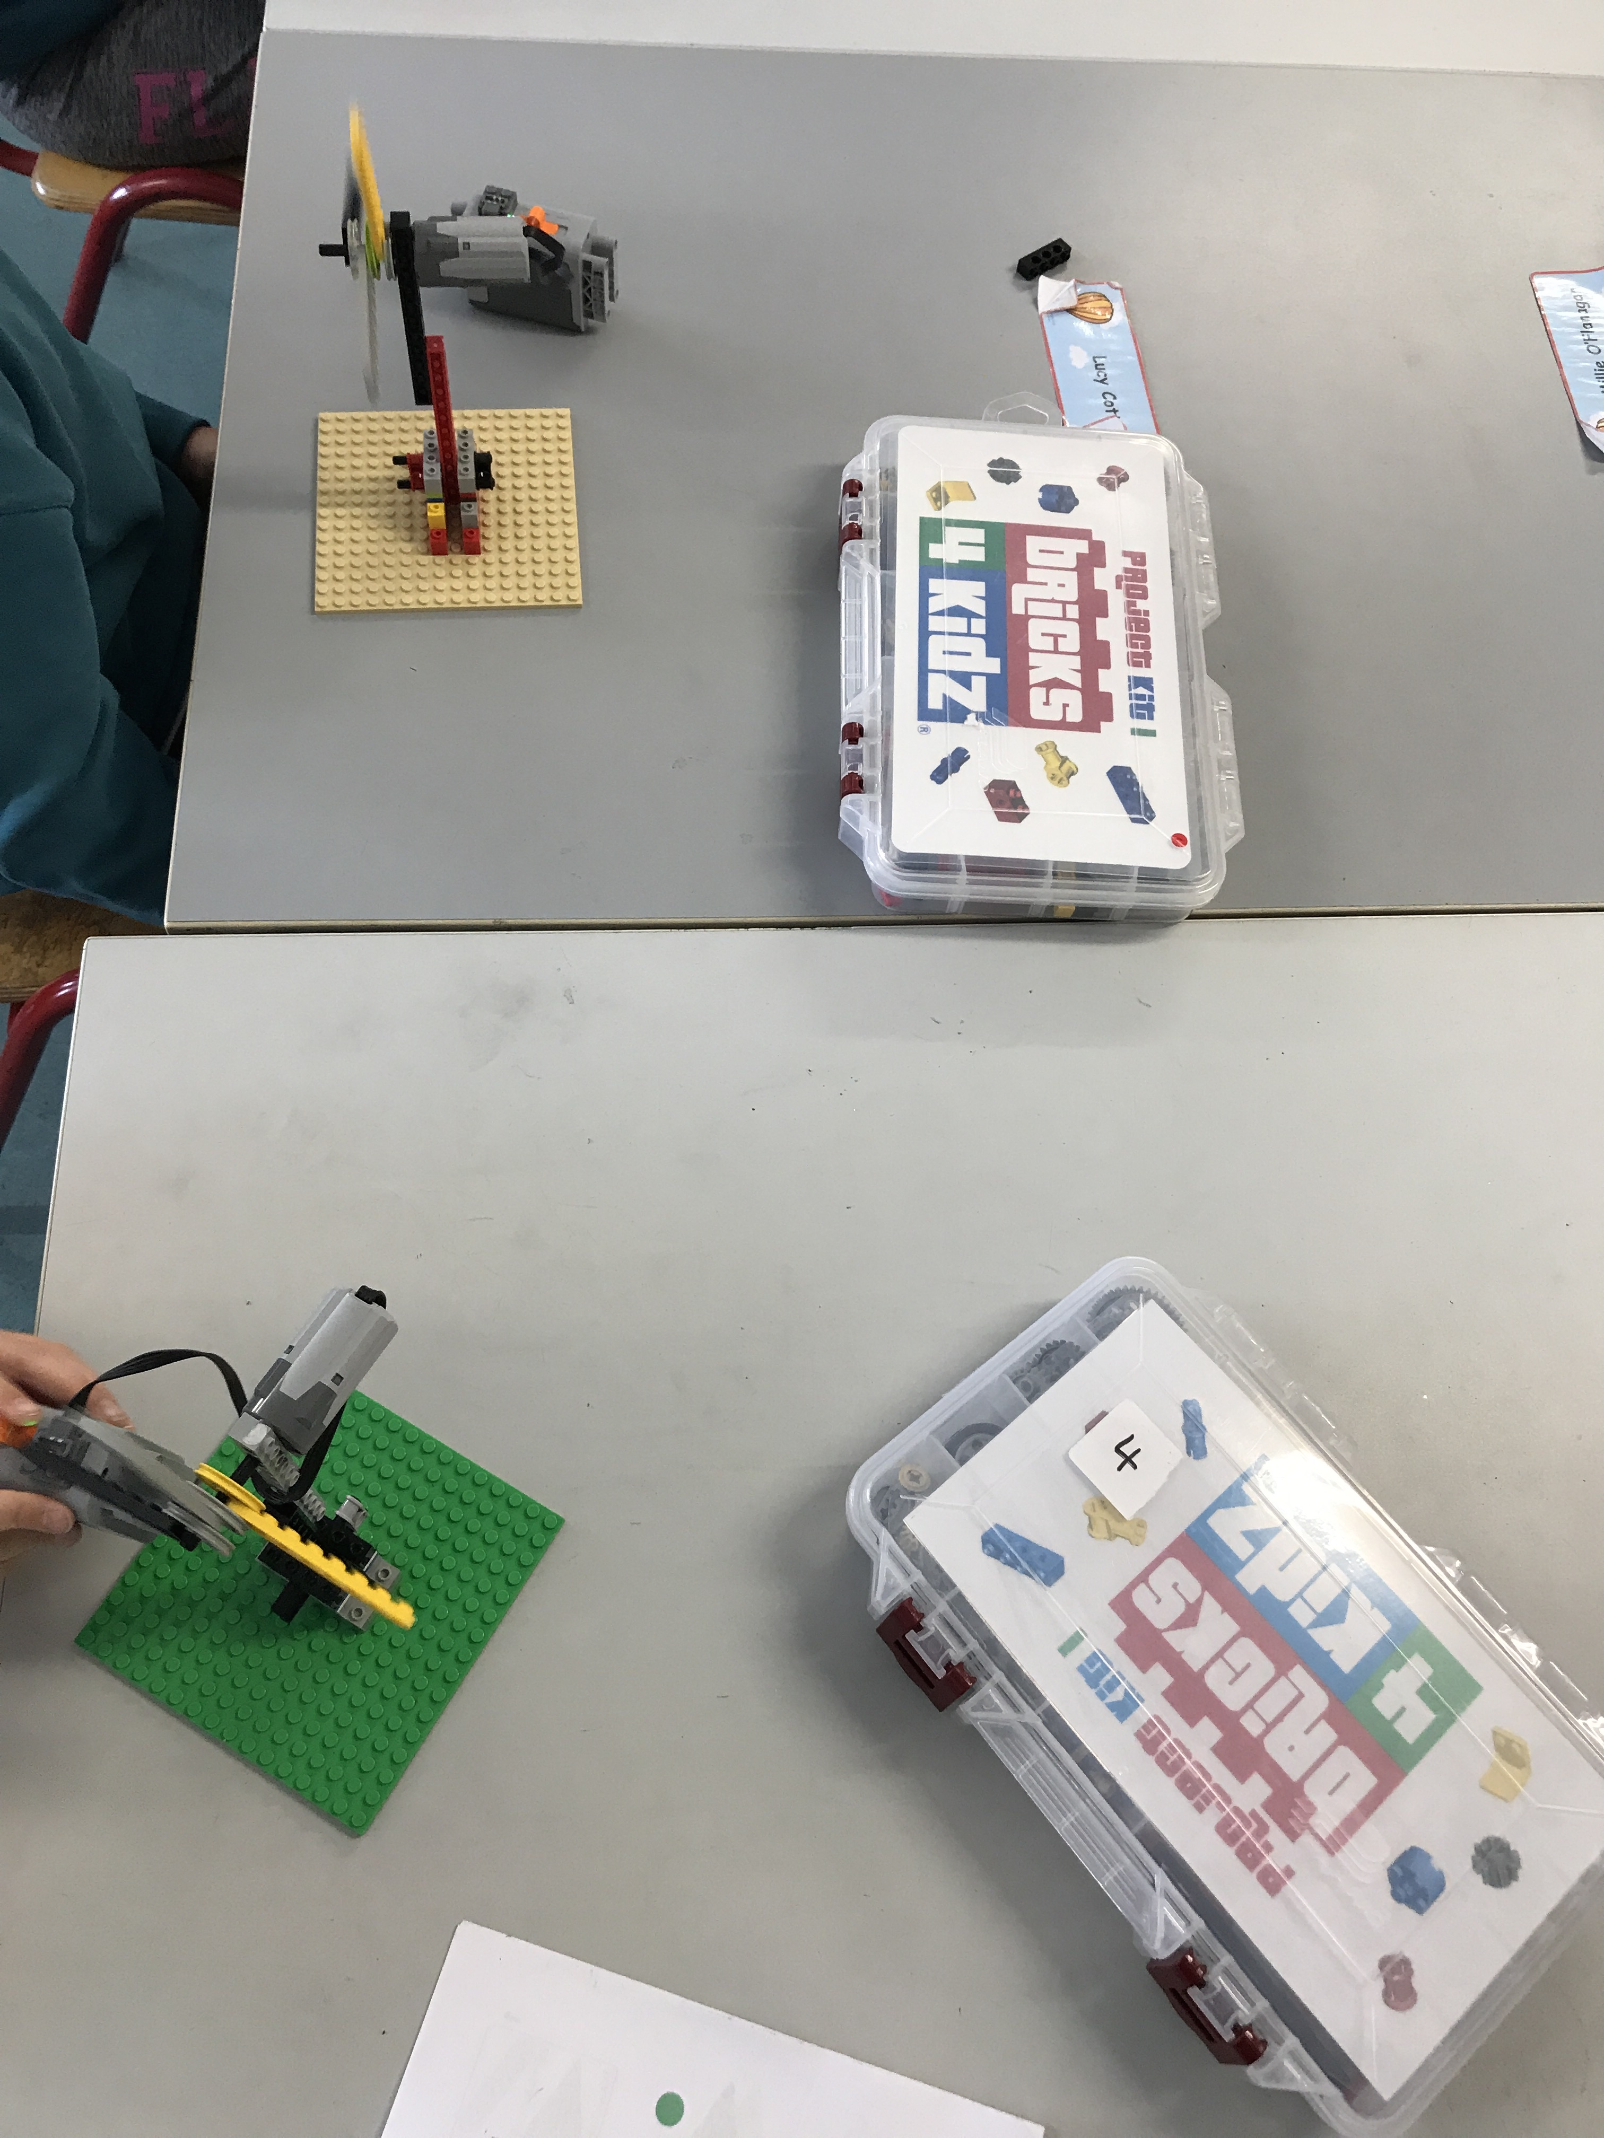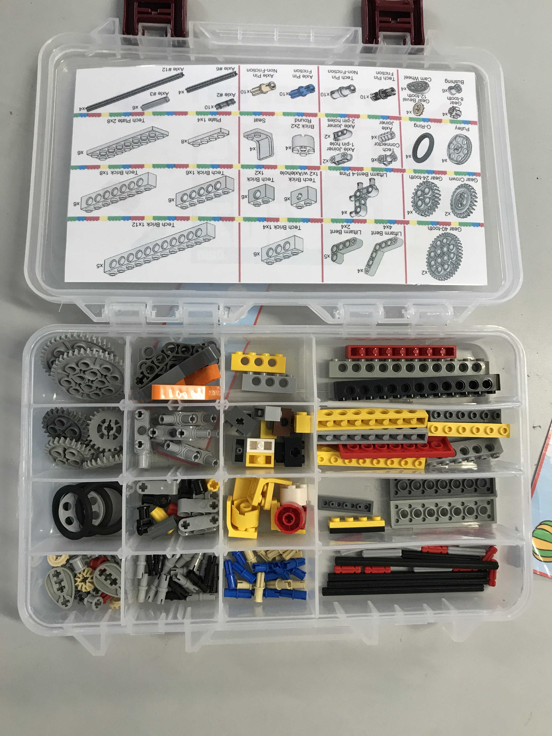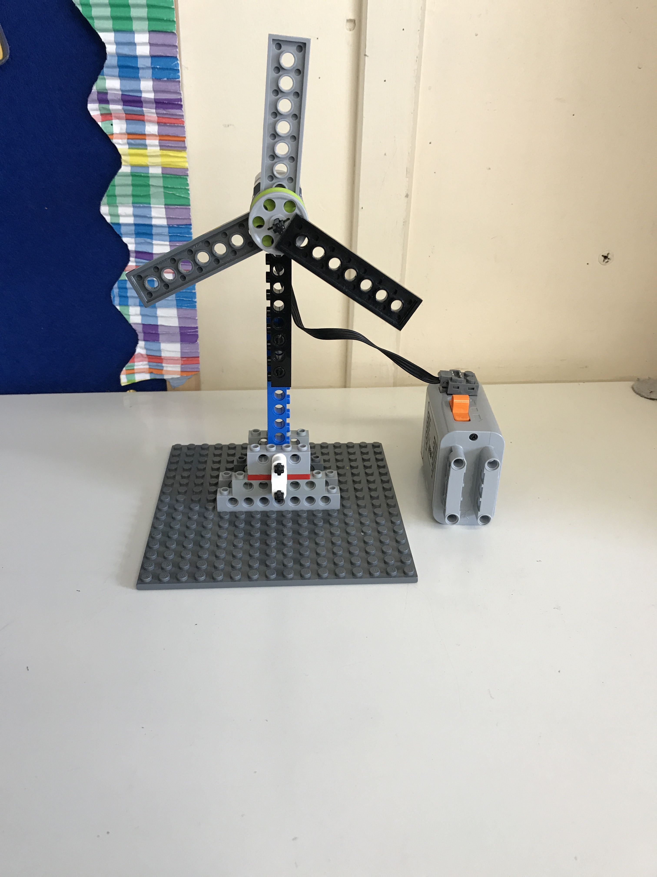

We also had a super day on Friday 20th where we all dressed up as our favourite character for book week. We had lots of different characters from our favourite books and everyone made a huge effort to have wonderful costumes!

